December 2020
2020 Woods Hole
Partnership Education Program (PEP)
Director’s Report

George Liles
Onjalé Scott Price

Table of Contents
2020 Overview 2
2020 Program 4
Roster 4
Same Program 4
Course 6
Supplementary Activities 7
Research Internship 8
Different Delivery 10
Program Data after 2020 11
Looking Forward 11
Appendix One: Participating Colleges and Universities, 2009-2020 13
Appendix Two: The PEP Model 15
Partnership Overview 16
Goals and Objectives 16
Guiding Principles 16
Program Components 17
Results, Outcomes, and Lessons Learned 18

2020 Overview
The Partnership Education Program (PEP) welcomed its 12th cohort in 2020, a class of 16 students from 13 colleges or universities, including five schools that were new to PEP and six Minority Serving Institutions or (MSIs) or HBCUs. PEP’s reach is broad and national, with students from 104 colleges or universities having now participated, including 32 Minority Serving Institutions (see Appendix One for the complete list of schools).

The 2020 program began much like the preceding 11 programs – we announced the program and called for applications in December. We recruited research mentors and this year we posted some potential research projects online where potential applicants could view the kinds of research opportunities PEP offers. We made recruiting trips in January and early February – the traveling recruiters were Ambrose Jearld, Kwanza Johnson, and George Liles. We did in-person recruiting at 14 colleges or universities, ranging from New Mexico and Texas to the Mid-Atlantic states to Southeastern seaboard states (Virginia, North Carolina, Georgia).

In early March the Selection Committee, chaired by Larry Alade and Kwanza Johnson, reviewed a large and impressive collection of applications. We made the difficult decisions and extended offers on March 21, with a caveat that read:

Please bear in mind that given the developing situation with the spread of the coronavirus disease (COVID-19), changes in federal, state, county, or local policies are likely. In addition, PEP’s partner institutions may enact bans, restrictions, or travel limitations that would preclude us from hosting PEP as planned in the summer of 2020. While we are continuing to plan our 2020 program, we must reserve the right to modify or cancel the program if the situation warrants over the next month or two.

By late March we had a class of 16 interns, 11 of whom came from the colleges and universities where we did in-person recruiting.

Toward the end of March, it became clear that the COVID-19 pandemic would likely impact the summer program and the staff began making contingency plans that ranged from a delayed start to an all-virtual program. The staff was in communication with the Woods Hole hosting institutions and with other intern programs throughout the country. The staff also maintained communication with our research mentors to determine if the potential projects could be done remotely. Some of the mentors were unable to offer projects that could be done remotely, and the staff began recruiting additional mentors who could provide research opportunities to students who are not in residence. In the end, the roster of 2020 PEP research mentors consisted of 11 scientists, six of whom were new to PEP mentoring.

By mid-April it was apparent that a residency program was unlikely, and the staff discussed options ranging from postponing the 2020 program to running a virtual program. The staff decided unanimously and without reservation that it was important to offer a 2020 program, because (1) the students we serve cannot afford to put their careers on hold and (2) the Woods Hole community cannot afford to take a break from our efforts to become a more diverse and inclusive community.

On April 20 we announced that PEP 2020 would be a virtual, online program. We contacted the students and discussed the program and all 16 elected to participate in the virtual program. The effort to build a virtual program is described in a publication in the ASLO Bulletin (“Same Program; Different Delivery” – https://aslopubs.onlinelibrary.wiley.com/doi/full/10.1002/lob.10414. Key features of the re-building included a redesign of the course, led by Course Director Benjamin Harden, and the hiring of additional staff, including a Career Development Coordinator (Kelly Luis), a Course Assistant (André Price), and a Computational Advisor (Luis Valentin-Alvarado). The move to online communications and activities was led by the PEP Coordinator, Joniqua Howard. Dr. Howard was the first PEP Coordinator (2010), and we were fortunate that she was available to reprise her coordinator role in a year when we were facing challenges of logistics, communications, and cohort building.

We were also fortunate that Onjalé Scott Price (PEP Coordinator 2011-15) was available to play a major role in the 2020 program, first in an advisory capacity as we switched to online communications and programming, and later in the summer in the leadership role when the PEP Director (Liles) took an extend medical leave. Onjalé assumed the position of Acting Director in mid-June and directed the program from week four through the end of the 2020 program and the staff debriefing week in mid-August, at which point Liles resumed the PEP directorship.

The PEP Senior Advisor Ambrose Jearld played a critical role in all aspects of the program, from planning through recruitment, selection, project matching, and mentoring of students and of staff throughout the 2020 program.

Note that the 2020 PEP staff consisted of PEP alumni (Luis 2015, Price 2012, Valentin-Alvarado 2016) and veterans of previous PEP summers (Howard 2010, Scott Price 2011-15). Other PEP alumni served as volunteer mentors and participated on panels in the career building component of the program.

The enthusiasm with which PEP alumni pitched in to help design and offer the 2020 virtual program was gratifying. In PEP’s 12th summer it became clear that PEP is more than a program – it is now a community.

2020 Program

Roster
Name | University
Andrea Regan Scott | University of North Carolina at Pembroke
Aundre Jackson | North Carolina Central University
Ayanna Butler | Howard University
Ayinde Best | Wheaton College (MA)
Christopher Sandoval | University of Texas at El Paso
Eli Ahiamadjie | Delaware State University
Hayden Stuart | New Mexico State University
Hector Dominguez | University of Texas at El Paso
Jailyn Dorsett | Delaware State University
Jaimy Jabon | University of Massachusetts Boston
Jose Cabral | University of Texas at El Paso
Katherine Muniz | Wellesley College
Kristen McCauley | Savannah State University
Quinn Bustos | New Mexico Institute of Mining and Technology (New Mexico Tech)
Stephen Galindo | Humboldt State University
Tiffany Windholz | Oklahoma State University

Same Program
Many aspects of the program remained unchanged in their purpose, only adapted to the virtual situation. As with in person, PEP met the student’s needs to successfully complete their coursework and internship; we sent laptops, a monitor, various cables and accessories, and provided funds to download required softwares. We matched each student with a PEP Advisor whom they met with throughout the summer and whom the students have since called upon for letter of support for other opportunities.
In the absence of organic connections facilitated by living on campus, intentional community building and connection to Woods Hole was built into every aspect of the virtual program (described throughout this report). We also sent the PEP students a care package of classic Cape Cod and Woods Hole mementos such as Cape Cod potato chips, chocolate from Ghelfi’s, a bag of sand from Stoney Beach, a PEP visor, “swag” from the science institutions, a Cape Cod bagel and Nobska Farms hot sauce.
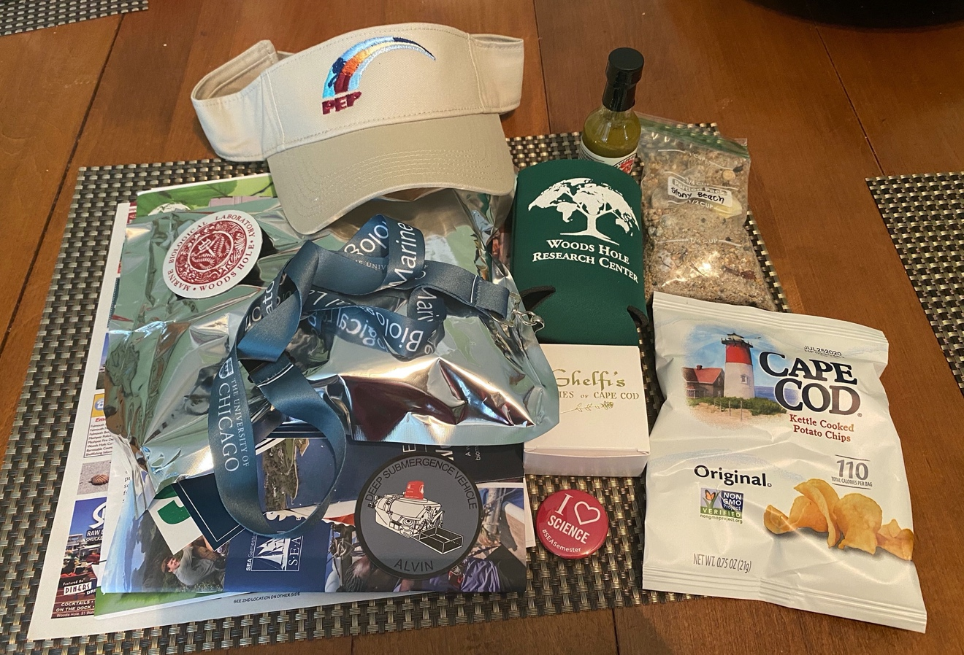
Figure 1: Woods Hole care package contents

Course
Offered online, the course’s purpose was unchanged: prepare students for success in their research projects by building understanding of key ocean and environmental science topics and helping them to advance their research skills. Given the data-heavy nature of these projects, and that of their upcoming PEP research project, we also invested more time than previous years to train interns in data analysis and visualization using R (software).
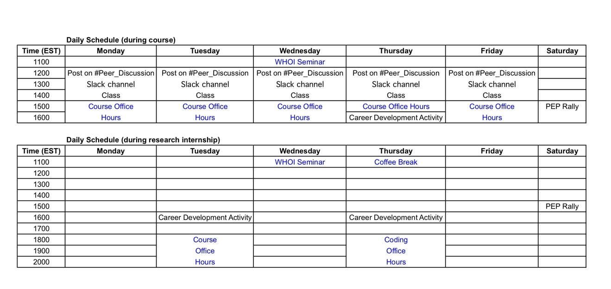
Figure 2: Course schedule where optional items are listed in blue.
Students were required to complete the assigned reading or assignment by 12 PM EDT and submit to the course website. At noon we randomly assigned students a peer partner to meet with for 30 minutes to discuss their answers to the questions posed and post comments or questions to a dedicated #Peer_Discussion Slack channel (the course director and assistant would respond to questions and comments). At 2 PM EDT we held a one-hour class on Zoom, where any unresolved questions from the Slack discussion were answered, additional insight was provided, and students discussed topics in break-out rooms. We also used this time for student presentations, guest speakers and advanced topic seminars. Advanced Topic seminars featured prominent scientists from all of the Woods Hole science institutions. Advanced Topics included marine policy, coastal climate change, deforestation, and ecosystems-based fisheries management. These seminars were designed to connect students to scientists in the ways they would through the various lectures and seminars hosted throughout Woods Hole during the summer.

Though PEP students could not sail aboard the SSV Corwith Cramer, they completed their mini-projects using data collected by previous PEP interns. The online format allowed us to recruit seven PEP Alumni Mentors to be on Slack and attend group working sessions to guide student groups through their mini-projects. The class culminated in a poster presentation session which we hosted as a series of Google Meets wherein guests could visit individual posters and ask questions of the presenting group.

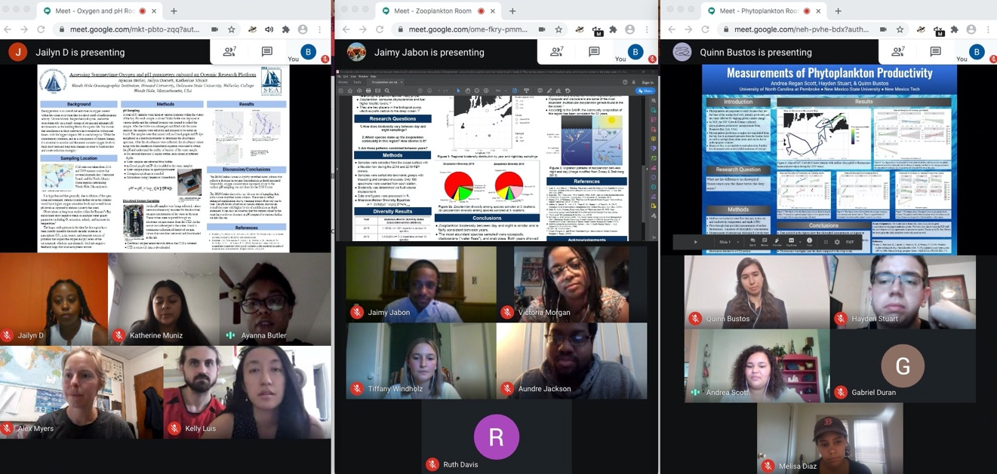
Figure 3: Mini-project presentations on Google Hangouts

Supplementary Activities
Throughout the summer, the Career Development Coordinator managed a 1-hour career development activity every Thursday at 1600 EDT. These activities and panels included: an individual development plan activity, a networking panel, how to craft a personal statement, how to apply to federal positions (specifically navigating the USAJobs website) and managing personal finances. Fifteen PEP Alumni participated on the various panels, including providing their own successful NSF GRFP and other fellowship application materials. Again, strengthening the bonds between the 2020 PEP students and the greater PEP Alumni family.

To help build community among the students and staff, the Program Coordinator hosted a ‘PEP Rally’ on alternate Saturdays. The events included: a virtual ‘House Party’, a cooking party, a game night, and a ‘real talk’ session, where the men and women had their own ‘talking circles’, led by Dr. Ambrose Jearld and Dr. Anna Martin-Jearld. We also provided the students their own Slack channel that was ‘hidden’ from all the staff and mentors. We later learned this channel was used quite frequently and the students hosted their own Zoom events amongst themselves.

During the research component, the PEP Coordinator hosted weekly ‘coffee breaks’, where interns could drop in as they wanted, to chat with each other and staff members. And as with every year, the interns designed their own t-shirts. The shirts were sent to them individually, with a 2021 Woods Hole calendar, to help reinforce their Woods Hole connection.

Research Internship
The PEP interns and the mentors were selected and matched prior to the COVID-19 pandemic. Once COVID-19 closures rendered PEP a completely virtual experience, we informed the students, and discussed options for projects with the mentors. Mentor matching changed, as some mentors were unable to support a virtual project while other mentors stepped up to take on 2 students. Most students had very minimal or no prior coding experience, and though the projects ranged greatly, they all included some form of data manipulation, coding and visualization. By increasing the use of R in the course, the addition of the Computational Advisor, and the willingness of PEP alum to help tutor, the PEP students were better prepared for the computational heavy research internship.

Each project and mentor-mentee relationship is different, as in every year, though this year there were many common themes and takeaways discussed during the debrief. Mentors overwhelmingly agreed communication was more critical this year than ever. Communication between the mentor and mentee, mentee and staff, mentors and staff and mentors with other mentors. During week 5 of the program, we held a mentor and staff session to discuss challenges and potential solutions, and all mentors agreed that session was very useful and want to continue those types of meetings (and more frequently) in the future whether in person or virtual. Additionally, mentors agreed the incorporation of R into their coursework laid a good groundwork for them to be successful in their research projects. Some specific recommendations for preparing the students even more in the future were discussed at our final debrief, along with other recommendations if the program is to be virtual again.

The mentors noted many challenges they faced were predictable yet difficult to overcome, such as home/family obligations interrupting scheduled meetings (for both mentors and interns), pressures of the social-political unrest, and the real-life immediate implications of the COVID-19 pandemic. Despite the many challenges and incredible flexibility required by all, the mentors were proud of the work their students completed and the presentations given at the symposium.

Name | Project Title | Mentor
Andrea Regan Scott | Examination of Scope 3 Greenhouse Gases for Woods Hole Research Institutions | Erin Bryant (SEA)
Aundre Jackson | Calcium carbonate fluxes in the Atlantic Ocean through sediment trap particulate inorganic and organic carbon data | Adam Subhas (WHOI)
Ayanna Butler | Visualizing Invisible Boundaries in the Ocean: Distribution of Water Masses in the Northeast U.S. Shelf | Stace Beaulieu (WHOI)
Ayinde Best | Distribution of Hermit Crabs and Echinoderms Along the Mid Atlantic Bight and Georges Bank | Dvora Hart (NOAA NEFSC)
Christopher Sandoval | Dive Behavior of Loggerhead Sea Turtles Along the Greater Atlantic and Southeast Regions of the United States | Joshua Hatch (NOAA NEFSC)
Eli Ahiamadjie | Identifying Sulfate Reducing Bacteria By Assembling Genomes From Eastern U.S. Salt Marsh Habitat | Elena Peredo (MBL)
Hayden Stuart | Study of the Distributions on Benthic Invertebrates | Dvora Hart (NOAA NEFSC)
Hector Dominguez | Nitrogen cycling within groundwater mixing zones affected by topography and population density in Long Island, NY | Meagan Gonneea (USGS)
Jailyn Dorsett | Exploring the Influence of Helical Swimming in Turbulence on Larval Dispersal | Lauren Mullineaux (WHOI)
Jaimy Jabon | Assembling Metagenomes of Sulfide Oxidizing Bacterial Communities in Eastern | Elena Peredo (MBL)
Jose Cabral | Tracking the Nearshore Sandbar Morphology using Photogrammetry at Head of the Meadow Beach, Massachusetts | Chris Sherwood (USGS)
Katherine Muniz | Investigating Carbon Fluxes with Sediment Traps in the Pacific Ocean | Adam Subhas (WHOI)
Kristen McCauley | Determining presence of haddock within the Stellwagen Bank National Marine | Genevieve Davis (NOAA NEFSC)
Quinn Bustos | What Strategies Can Help Plastic Pollution Reduction Campaigns Engage and Interact | Erin Bryant (SEA)
Stephen Galindo | Nitrogen Cycling in the Yucatan Karst Subterranean Estuary | Meagan Gonneea (USGS)
Tiffany Windholz | Detecting and Mapping Abrupt Landscape Change in Permafrost Regions of Siberia | Sue Natali (WHRC)

Different Delivery

The course component required students to work in pairs, groups and collectively, and the addition of the Advanced Topics served to connect the students to Woods Hole scientists. Including PEP alumni in the mini-projects and in almost all the career development activities, helped to build connection between this cohort and the greater PEP alumni family. The students were also responsible for facilitating the panel discussions and follow up communications with participants of the career development activities, requiring them to take ownership and make those connections.

Without the ability to visit the students in their cottages or talk to mentors in their labs, we relied heavily on Slack (and online communication platform), phone calls and video call (Zoom and Google Hangouts). During the course we were able to check in with students easily every day and began to build trust and community. During the research component the staff needed to make more of an effort to check in with each student individually at least a few times a week and check in with mentors just as often.

The culminating research symposium, which is usually held in the Madden Center of SEA, was hosted via Zoom Webinar and boasted over 100 attendees. This provided an opportunity for the interns to present their research in a scientific symposium and reach an audience wider than the Woods Hole community. Following the symposium, a private graduation was held.

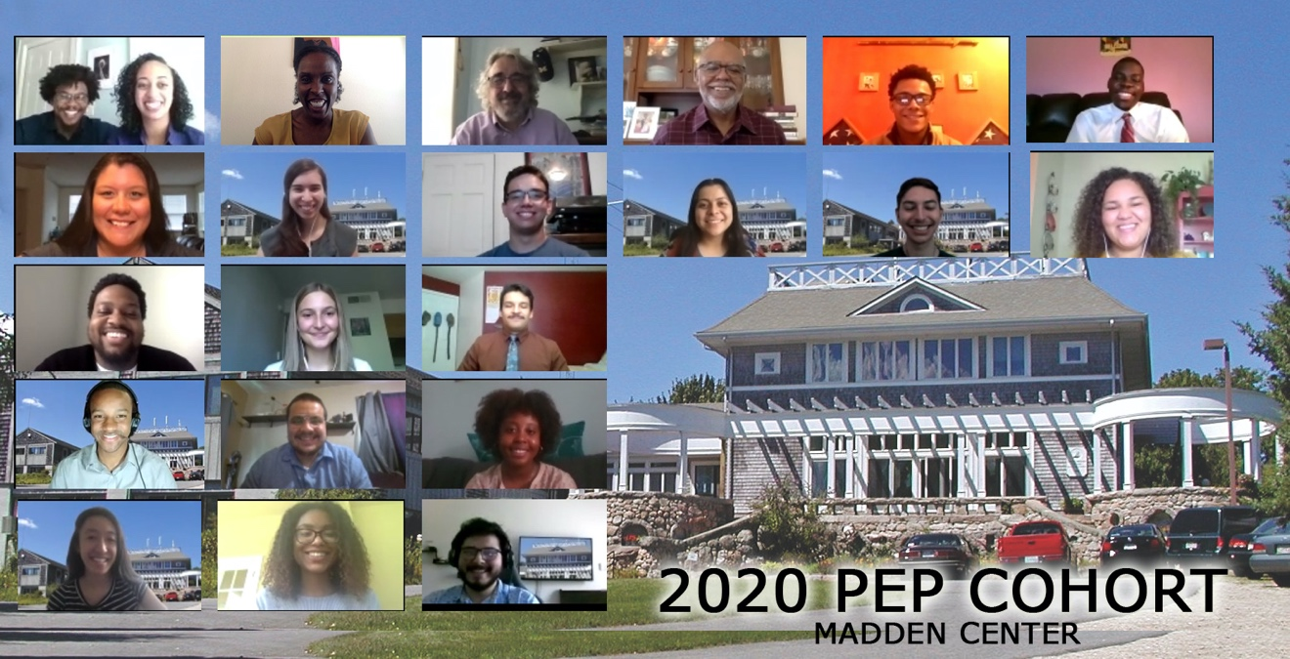

Figure 4: PEP 2020 Graduation

Program Data after 2020
The 2020 PEP cohort was drawn from 13 colleges or universities, five of which had not previously participated in PEP. The program has now attracted students from 104 colleges or universities, including 32 HBCUs or MSIs (full list below).

In twelve years (2009-2020), 183 students have completed PEP. Just over half (94) of the 183 PEP alumni have come from MSIs. PEP graduates include 92 women and 67 men from minority groups under-represented in science. Additionally, PEP has provided career building opportunities for three graduate students (all African American) who served as coordinators in 2010-2020.
PEP students’ ethnic identities (as self-identified), 2009-2020: African (2), African- American/Black (85), Asian/Chinese/Thai (4), Bengali (1), Bi-Racial/Mixed (12), Cape Verdean (1), Caucasian/White (16), Filipino (2), Hispanic or Latinx (35), Indian (1), Japanese American (1), Mexican or Mexican American (4), Native American (7), Native Hawaiian (1), Pacific Islander (2), Puerto Rican (1), West Indian (2), Declined to identify (6).

Looking Forward
In November of 2020 we are planning the 2021 program while facing continuing uncertainty due to the ongoing pandemic. Our host campus (Sea Education Association) currently has a limited number of students in residence and the SEA staff is learning how to have programs on campus while keeping students and staff safe. We are hopeful that we can run a residency program in 2020, but we know that we can provide a good remote program should that be necessary again in 2021.

As of this writing, we do not yet have the 2020 report from our independent program evaluator, Dr. Emorcia Hill. Dr. Hill’s report will include recommendations for program development in 2021 and beyond. In advance of that, our own program debrief in August convinces us that PEP will be well served to continue with the expanded staff, whether we return to a residency program or continue with a virtual program. We also learned from the 2020 program that our research mentors value regular contact with PEP staff and with other mentors throughout the summer.

Heading into our 13th year, PEP is a maturing program that is now embedded in the planning of the seven hosting institutions (our six Woods Hole partners and the University of Maryland, Eastern Shore). This fall we have established five working groups to formalize or “institutionalize” PEP’s position in the Woods Hole community and to support the national effort to diversify STEM education. One group led by Kwanza Johnson is working to establish PEP Alumni Association. A PEP Publications Group led by Onjalé Scott Price is identifying outlets and preparing manuscripts to share the PEP Model with a national audience. Other groups are addressing PEP Governance, PEP Funding, and PEP 2021 program planning.

At the close of 2020, PEP planners are looking beyond the 2021 summer, seeking to identify ways PEP can increase its impact on Woods Hole and on the nation by providing additional career building opportunities for PEP participants.

Appendix One: Participating Colleges and Universities, 2009-2020

Institutions (104) that have sent students to PEP:
(Italic = Historically Black Colleges and Universities and/or MSI) (31)

Amherst College
Arkansas State University (2)
Auburn University
Barry University
Beloit College
Bethune Cookman University (2)
Boston College
Bridgewater State University (2)
Bowdoin College
Bowie State University (2)
Brown University
California Polytechnic State University
California State University of Bakersfield
California State University Chico (2)
Cheney State University
City University of New York
Coastal Carolina University
College of William and Mary
Columbia University
Cornell University (2)
Delaware State University (3)
DePaul University
Dillard University

East Carolina University
Eastern Michigan University
Elizabeth City State University (2)
Fisk University
Florida A&M University (3)
Fort Velley State University
Georgia State University (2)
Green Mountain College
Grinnell College
Hampton University (2)
Harvard University
Howard University (3)
Humboldt State University (14)
Illinois State University
Juniata College
Kentucky State University

Loyola University Chicago
Morehouse College (5)
Morgan State University (2)
New Mexico Institute of Mining and Technology
New Mexico State University, Socorro
New York City College of Technology
New York University, Abu Dhabi
North Carolina Agricultural and Technical State University (5)
North Carolina Central University (4)
Northeastern
Nova Southeastern University
Oklahoma State University
Philander Smith College
Rice University
San Jose State University
Savannah State University (5)
Skidmore College
South Carolina State University
Southwestern College
Spelman College (2)
St. George’s University
St. Mary’s College of Maryland
St. John’s University
SUNY Albany
SUNY Maritime College
Syracuse University

Temple University
Texas A&M
Tuskegee University (5)
University of Arkansas, Fayetteville
University of Arkansas, Pine Bluff
University of California, Berkeley
University of California, San Diego (2)
University of California, Santa Cruz (3)
University of Central Florida
University of Delaware
University of Florida
University of Hawaii
University of Maryland – Baltimore County
University of Maryland, College Park (2)
University of Maryland, Eastern Shore (13)
University of Massachusetts, Amherst (2)
University of Massachusetts, Boston (3)
University of New England (2)
University of New Haven
University of North Carolina, Pembroke
University of North Carolina, Wilmington

University of Puerto Rico, Humacao (2)
University of Puerto Rico, Mayaguez (2)
University of Rhode Island
University of Rochester
University of San Francisco
University of South Carolina, Columbia (2)
University of South Florida
University of Tampa
University of Texas, Arlington
University of Texas, El Paso (5)
University of Texas, Rio Grande Valley
University of the Virgin Islands (2)
University of Wisconsin, Stevens Point (2)
Virginia Commonwealth University
Wellesley College (2)
West Virginia University
Western Washington University (2)
Wheaton (MA) College

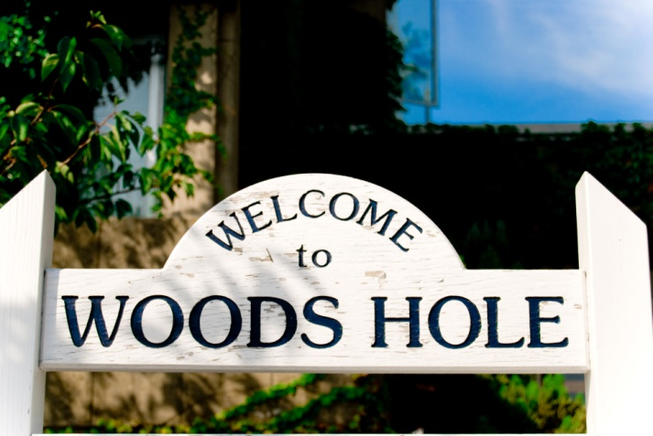

Appendix Two: The PEP Model

Woods Hole Partnership Education Program Model

Key Design Elements

Partnership Overview
Participating Organizations. The Partnership Education Program (PEP) is a social intervention designed to address a specific societal issue, that is, the underrepresentation of Blacks, Hispanics, Native (Indigenous) American and Asian Americans (hereafter referred to as underrepresented minorities (URM)) in the marine and ocean sciences. PEP is a project of the Woods Hole Diversity Initiative (DI), and a multi-institutional effort with the overarching goal to promote diversity in the Woods Hole Science Community, via a 2004 Memorandum of Agreement (MOU) signed by the six CEOs of participating institutions and recommitted in 2012.
Eligibility. PEP is designed primarily for college juniors and seniors. Prerequisite coursework includes oceanography, marine and/or environmental science, or some combination of biology, chemistry, geology, and physics. Applications are welcome from students from all backgrounds and especially students from groups underrepresented in the marine and environmental sciences. Housing, tuition, travel allowance, room and board, and a stipend are provided to students. A Student Contract is in place and includes language about adherence to organizational policies.

Goals and Objectives

Diversity Initiative-Related Goals
- Be a resource that supports students in achieving their full potential within the Woods Hole research, learning, and work environment regardless of their race, religion, color, creed, gender, age, national origin, citizenship status, sexual orientation, physical or mental ability, socio-economic status, or veteran status.
- Cooperatively undertake recruitment, retention and mentoring programs that will result in a diverse group of students (and ultimately) employees and postdoctoral researchers in ocean sciences, biological sciences, geosciences, and ocean engineering and technology, marine and environmental policy activities undertaken by the Woods Hole scientific and educational organizations.

PEP-Specific Objectives
- Member Institutions develop outreach/mentoring/intern programs at and among the institutions by making a concerted effort to attract individuals from underrepresented groups and to offer them support (housing, board, and funding) to be in Woods Hole.
- Offer students from under-represented groups the opportunity to study, conduct research, and receive training in their areas of interest, working in labs with leading researchers in marine and environmental sciences.
- Provide a first-hand introduction to emerging issues and real-world training in the research skills students need to advance in science, either as graduate students or bachelors-level working scientists.

Guiding Principles
Selection Criteria. PEP established selection criteria that broaden the diversity of the available pool of students for the ocean and marine sciences. PEP shifted from traditional quantifiable criteria such as GPA, test and broad scores to more expansive and holistic factors. The PEP selection process takes into account a broad array of factors that include the applicant’s academic, educational, social, cultural, and personal background characteristics.
Critical Mass. Each summer, PEP brings 15 students to Woods Hole. This is consistent with our belief that to have meaningful impact and to effect change, a sufficient number of individuals from the requisite racial/ethnic and academic backgrounds must be introduced into the Woods Hole Community.
Resource Availability. PEP benefits from resources that are allocated from local institutions based on a specific formula. This aligns with our perspective that programs offering summer experiences must provide a level of financial support that is sufficient for efficient program operations and constantly be alert to funding prospects.
Management and Administration. Over its 10 years, PEP has stabilized its management and administration infrastructure to include personnel whose race/ethnic, academic and career/professional backgrounds are well aligned with student participants. PEP sees these synergistic affiliations as essential to its creation of an environment of support.
Monitoring and Evaluation. Continuous self-reflection and awareness coupled with responsive and strategic actions are a hallmark of PEP design, development, and sustainability planning. Thus, informal and formal evaluative mechanism have been in place since the program’s inception.
Diversity Training. Diversity (and inclusion) are at the forefront of PEP’s work. To ensure that the Woods Hole community has a fuller and PEP-aligned understanding of the tenets and underpinnings of diversity, annual trainings are provided.

Program Components
PEP is an integrated program that includes two primary components as well as supplemental activities. The two primary components are an educational credit-bearing course and an experiential research internship. Supplemental activities include a variety of career, personal, and professional development
Education. PEP’s educational component is a four-credit, four-week course (Global Climate Change) offered through the University of Maryland Eastern Shore (UMES). The course is organized as a series of modules, each of which addressed specific topics and pertinent issues related to global climate change. Each module includes lectures and labs led by scientists from DAC member organizations. The course description (content and structure) was submitted to the UMES Curriculum Committee for approval, course number, and credit assignment. Students can request transfer of credits from UMES to their own institution, added to their transcript and used to fulfill degree requirements in their respective institution. Course instructors come from the scientific ranks—as well as doctoral students at Woods Hole Oceanographic Institution—and each has responsibility for a specific module. In PEP’s Year 10, the opportunity for a research cruise on the SEA-owned research vessel (SSV Corwith Cramer), presented itself and consequently changes were made to accommodate the ship’s local availability.
Research Internship. The experiential learning component takes the form of a six-to-ten-week mentored research internship in a lab in one of the partner research institutions. Each participating student is matched with a locally based research scientist who submits a short description of the proposed project prior to student assignment. Projects are closely related to the scientists’ primary interest and involve tasks that are a part of current work or that would guide future areas of research that respond to major scientific questions.
Supplemental Activities. Students are provided a variety of supplemental activities that leverage resources within the Woods Hole community, including Scientific Ethics, Writing, Public Speaking, and SUCCESS Workshops, as well as field trips to museums and New England sites related to science, fishing, and whaling.

Results, Outcomes, and Lessons Learned
PEP is a seven-institution collaboration that includes Woods Hole institutions and UMES. In ten years (2009-2018), PEP has brought to Woods Hole 153 students from 92 colleges and universities, including 29 Minority Serving Institutions (MSIs), and public and private colleges and universities representing all geographic areas of the United States. Just over half (79) of the 153 PEP students are from MSIs. PEP graduates include 80 females and 51 males from groups underrepresented in science.
Ten years of PEP has underscored the unquestioned need for commitment. Dedication to the partnership’s goals and objectives, and to the program’s design elements has been the sustaining force. From this foundation, we look with optimism to PEP’s next 10 years and the prospects and opportunities that lie ahead.

Contact: George Liles
George.liles@noaa.gov

